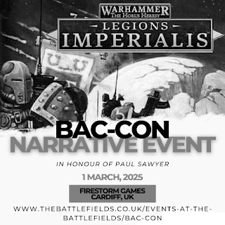

The Battle for Rynd’s World
Event mission pack

Timetable:
09:30 – Arrival & Registration
10:00 – 13:00 – Game One
13:00 - 14:00 – Lunch
14:00 - 17:00 - Game Two
17:00 – 17:30 – Awards & Raffle Prizes

Events Page:

https://sumocatretro.wixsite.com/bac-con2025

Please note that Bac-Con is intended as a Narrative event, for attendees to have fun and contribute to a good cause while they are at it. Although results of the games are recorded, equal weighting in scoring is given to sportsmanship and for painting so bear this in mind when both creating your army and playing. Please also remember that these games relate to fictional creations fighting over imaginary Grox (bacon) butties, and battles should be fought in an appropriate spirit.

Game One: 2000pts

“Battle at the Farm”
“An army marches on its stomach” – unknown Warlord of Ancient Terra

Scenario: Battle Barges and Troop carriers have moved into position above Rynd’s World. Loyalist and Traitor alike have been ordered to capture as many meat-processing facilities, Grox herds and as much farmland as possible to ensure that stocks are maintained for the war effort.

CONQUEST layout– use standard setup/deployment rules from the main rulebook.
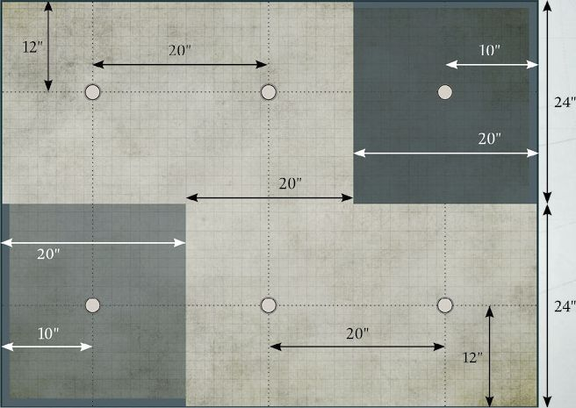

Primary Objective
The game lasts 4 turns, with scoring only at the end of the final turn.
- 3 VP for holding the objective in the enemy deployment zone
- 1 VP for holding each objective in the neutral area
- 0 VP for holding the objective in your own deployment zone

Secondary Objective
“Carnage”, with the following VPs awarded relating to the total percentage of the enemy army having been destroyed by the end of the game.
- 3 VP for 80% of the opposing army
- 2 VP for 60% of the opposing army
- 1 VP for 40% of the opposing army

Special Rules
“Fog of War”: The sounds of descending drop ships, bolter fire and explosions have sent the millions of terrified Grox into a stampeding frenzy. This has thrown thousands of tonnes of dust up into the atmosphere, drastically reducing visibility of the clashing armies.
For turns 1 & 2 each weapon’s maximum range is reduced to 18” (does not apply to barrage/heavy barrage weapons).
Game Two: 2000PTS Doubles (1000pts each)

“Bring home the Grox Meat”

Scenario: Loyalist and Traitor forces have both staked out their claims on the surface. As the vicious fighting continues, and thousands of Astartes lie dead amongst the Grox herds, the leadership of both sides are made aware of a great prize: Vehicles carrying ‘prime cuts’, specially cloned Grox whose meat is reportedly of great flavour, have become isolated in no-mans land. Their value is immeasurable, and marines from both factions close in to claim them.

Rules for Doubles game:
Both teams effectively play as ‘one force’ (nominate a player on each side to roll for Initiative and setup) and will share victory or defeat, with the following amendment designed to speed up play: During the movement phase, when it is one sides turn to move, both players may move a single unit. This means that effectively each team is moving two units during their side’s activation.
The First Fire/Advanced Fire and Close Combat phases proceed as normal.

NO MAN’S LAND layout– use standard setup/deployment rules from the main rulebook.
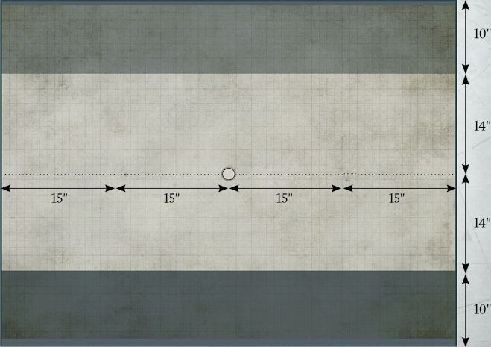

Primary Objective
Place the ‘Prime Cuts’ vehicle/objective marker in the centre of the board. Do not place it within obstructing terrain or a building. Any unit within 1” of the vehicle at the end of the turn, if no enemy units are within this distance, may commandeer it. From the following turn that player may move the vehicle up to 7” in any direction during the movement phase. It cannot be moved into difficult or obstructing terrain. The other player may capture the vehicle themselves and take control if they have units within 1” of it with no competing enemy units at the end of following turns.

The game lasts 4 turns, with scoring only at the end of the final turn.
- 5 VP if the vehicle has been moved within 12” of the team’s table edge, and no enemy unit is within 1” of it.
- 3 VP if the vehicle has been moved from the table’s central point and is within the team’s half of the table, and no enemy unit is within 1” of it.
- 2 VP if the vehicle is still on the table’s central point, is under control and no enemy unit is within 1” of it.

NOTE: The ‘Prime Cuts’ Vehicle cannot be targeted purposefully, but if hit by any weapon incidentally (such as a barrage or template weapon) it will automatically be destroyed and that team suffer -8VP; both commanders will then be stripped of their rank and turned into Servitors for such an egregious failure.

Secondary Objective
At the end of each turn the turn the team that destroyed the most enemy detachments (which also includes those which have fled or otherwise been removed from the board) get 1VP. If equal numbers have been destroyed on each side, both teams receive 1VP.

